Project Design Phase-II
Data Flow Diagram & User Stories

Date | 07 August 2026
Name | Livin Renith V L
Project Name | Shopez :E-commerces
Maximum Marks | 4 Marks

Data Flow Diagrams:
The Context Diagram views the entire Shopez application as a single system process and illustrates its interactions with external entities..

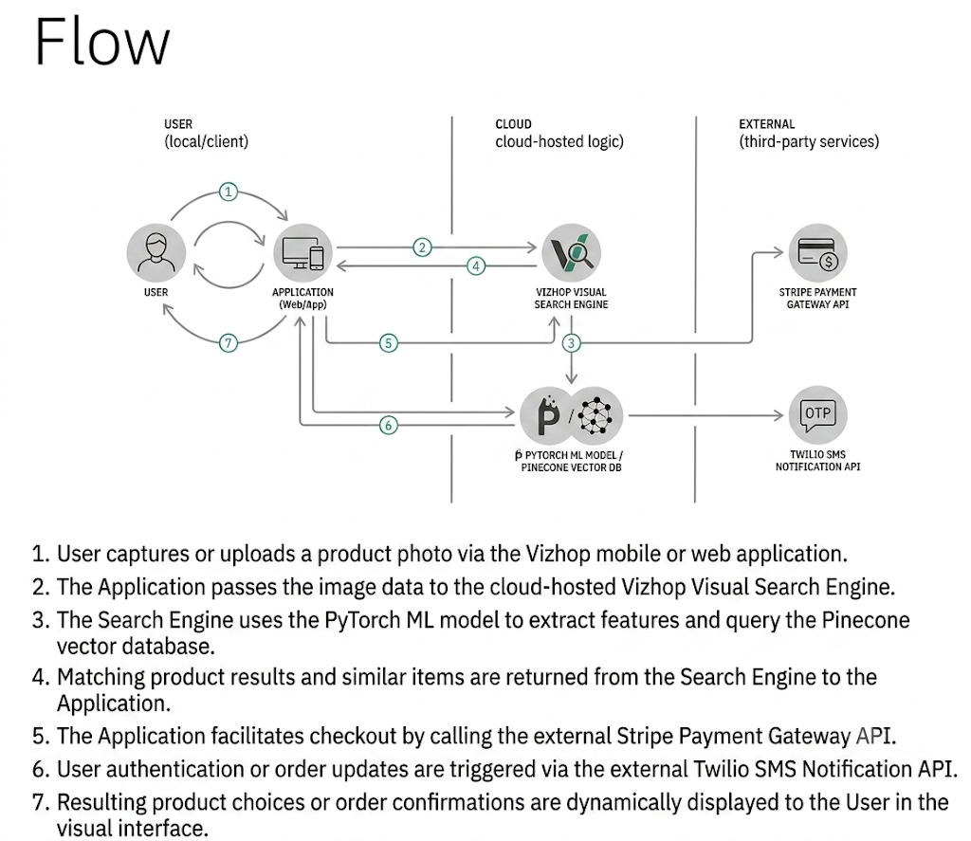
User Stories
Use the below template to list all the user stories for the product.
User Type | Functional Requirement (Epic) | User Story Number | User Story / Task | Acceptance criteria | Priority | Release
Customer (Mobile user) | Registration | USN-1 | As a user, I can register for the application by entering my email, password, and confirming my password. | I can access my account / dashboard | High | Sprint-1
 |  | USN-2 | As a user, I will receive confirmation email once I have registered for the application | I can receive confirmation email & click confirm | High | Sprint-1
 |  | USN-3 | As a user, I can register for the application through Facebook | I can register & access the dashboard with Facebook Login | Low | Sprint-2
 |  | USN-4 | As a user, I can register for the application through Gmail | I can register & access the dashboard with Google Login | Medium | Sprint-1
 | Login | USN-5 | As a user, I can log into the application by entering email & password | I can log in successfully and view my profile | High | Sprint-1
 | Visual Search | USN-6 | As a user, I can upload or take a photo to search for visually similar products. | App returns matching products within 2 seconds | High | Sprint-1
Customer (Web user) | Product Discovery | USN-7 | As a user, I can view 360° product previews and short video reviews on product pages. | Video and 360° views render smoothly without lag | Medium | Sprint-2
Customer Care Executive | Cart & Checkout | USN-8 | As a user, I can checkout quickly using 1-click payment (Stripe/Apple Pay) as a guest. | Order is placed and receipt is generated instantly | High | Sprint-1
 | Visual Search | USN-9 | As a web user, I can drag and drop an image into the search bar to find products. | Search engine processes image and displays visual matches | High | Sprint-1
 | Order Tracking | USN-10 | As a web user, I can track my active order status and delivery updates in real-time. | Live delivery map and tracking timeline are updated | Medium | Sprint-2
 | Order Support | USN-11 | As a customer care agent, I can view user order details and handle return/refund requests. | Ticket status updates to "Resolved" and refund is initiated | High | Sprint-2
Administrator | Catalog & AI Management | USN-12 | As a customer care agent, I can view user order details and handle return/refund requests. | New products immediately appear in visual search queries | High | Sprint-1

